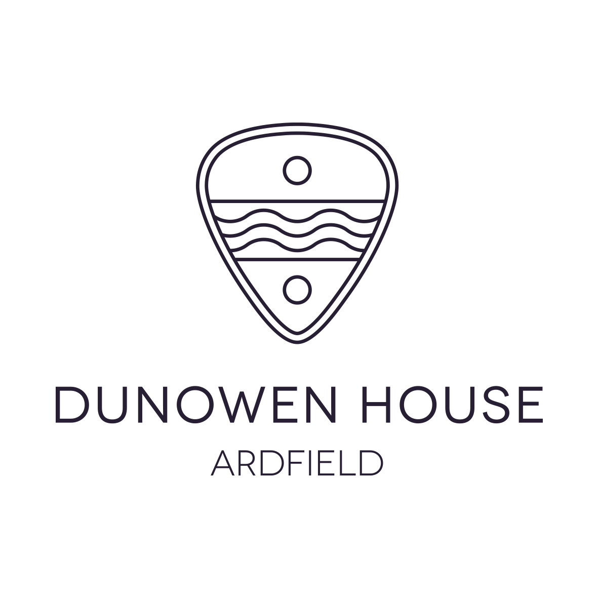
Sample Dinner Party Menu

Starters:
Thai spiced pumpkin soup
Dunowen House “half the garden” vegetable soup
Union Hall Crab Cakes with seasonal organic leaves
Clonakilty black pudding & caramelised apple salad
Butternut Squash & Smoked Gubbeen Cheese Tartlet & organic leaves
Heirloom Tomato & Smoked Sundried Tomato Pesto Bruschetta
************

Main Courses:
Pan Roasted Chicken with wild mushroom & sherry cream, Clonakilty Black Pudding and honey glazed parsnips

Slow cooked Inchydoney Beef with red wine, Spanish herbs & spices, Gubbeen Pancetta & black olives

Classic Beef Bourguignon served with creamy mashed potato

Baked Union Hall Hake with Herb Crumb Crust served on spiced Puy lentils

Oven Roasted Fresh Salmon Darne marinated in Thai herbs & spices

Selection of Indian Curries, including Butter Chicken, Red Lentil Dahl & Masala Chickpeas (best served as a buffet for sharing among a group)

Sauté of Chard, Carrot and Chickpea with a Lemon & Herb yoghurt dressing
(All the above dishes served with a selection of seasonal sides)

Desserts:
Salted Caramel Chocolate Brownies with White Chocolate & Raspberries
White Chocolate Cream Pots with a Fresh Fruit Salsa
Apple & Blackberry Crumble
Baked New York Cheese Cake
Plum or raspberry Frangipane Tart

We specialize in using homegrown & locally sourced produce of West Cork wherever possible. Dinner choices to be made and given to us at least 2 days in advance. A minimum of 6 orders per menu item chosen required. Please inform us of allergies or dietary requirements in advance.

